PROGRAM 7

/\* Program to use conditional statements: if-else \*/

#include<stdio.h>

int main()

{

int number;

printf("Enter an integer:\n");

scanf("%d", &number);

if(number%2==0)

{

printf("%d is an even integer", number);

}

else

{

printf("%d is an odd integer", number);

}

return 0;

}

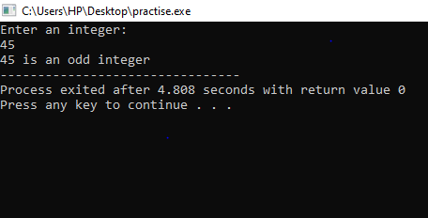

/\* Program to demonstrate if else ladder \*/

#include<stdio.h>

int main()

{

int number1, number2;

printf("Enter two integers:");

scanf("%d%d", &number1, &number2);

if(number1==number2)

{

printf("Result: %d=%d", number1, number2);

}

else if(number1>number2)

{

printf("Result: %d>%d", number1, number2);

}

else

{

printf("Result: %d<%d", number1, number2);

}

return 0;

}

